New Business

Contents

**BASICS OF NEW BUSINESS** 2

1. New Business 2

1.1 Cycle of New Business 2

1.2 Documents generated for New Business 2

1.3 Type of New Business Policy 2

1.4 Broker Fee 3

1.5 Skip Days Logic 4

1.6 Mails in New Business 4

1.7 Payment Website 5

1.8 Referral 6

1.9 New Business Premium Calculation 8

GLOSSARY 9

# **BASICS OF NEW BUSINESS**

# New Business

New policies purchased in a particular year of any Product (Home, Landlord and Motor)

## 1.1 Cycle of New Business

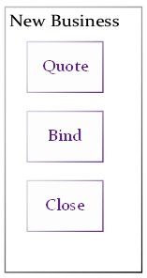

1. **New Business Quote**- The process of purchasing a new policy
2. **New Business Bind**- Process where the user is agreeing to buy the policy at the quote provided
3. **New Business Close**- It is a process where user agrees to close (SVU specific) the policy at the agreed quote

## 1.2 Documents generated for New Business

|  |  |  |
| --- | --- | --- |
| Events | List of Documents | |
| Quote Response | Quote Schedule  (pdf) | Broker Text Schedule (rtf, HTML, txt) |
| Bind Response | Policy Schedule  (pdf) | Broker Text Schedule (rtf, HTML, txt) |
| Close Response | Certificate of Insurance (pdf) | Broker Text Schedule (rtf, HTML, txt) |

## 1.3 Type of New Business Policy

1. **Annual Policies**

Annual Policy is one year policy where broker/Customer has to pay premium of whole year at once.

In case of annual policy the annual premium is generated which broker has to pay directly to IAL.

**2. Installment Policies**

In case of Installment policy the premium is generated per month and IAL has given the functionality to choose the Particular date in the month on which client is comfortable in paying premium.

The same date will be continued for each month

For E.g.

Policy Start Date-1/1/2017

Policy End Date-1/1/2018

Installment Date-10

|  |  |
| --- | --- |
| Installment | Amount |
| 10-Jan-17 | 100 |
| 10-Feb-17 | 100 |
| 10-Mar-17 | 100 |
| 10-Apr-17 | 100 |
| 10-May-17 | 100 |
| 10-Jun-17 | 100 |
| 10-Jul-17 | 100 |
| 10-Aug-17 | 100 |
| 10-Sep-17 | 100 |
| 10-Oct-17 | 100 |
| 10-Nov-17 | 100 |
| 10-Dec-17 | 100 |

## 1.4 Broker Fee

The broker charges the brokerage fee for services such as purchases, sales, and advice on the transaction.

Broker fee is collected as part of first installment i.e. if broker enters the Broker fee than it gets added in First Installment of the policy.

For E.g.

Policy Start Date-1/1/2017

Policy End Date-1/1/2018

Installment Date-10

Broker Fee + Broker Fee GST=110

|  |  |
| --- | --- |
| Installment | Amount |
| 10-Jan-17 | **210** |
| 10-Feb-17 | 100 |
| 10-Mar-17 | 100 |
| 10-Apr-17 | 100 |
| 10-May-17 | 100 |
| 10-Jun-17 | 100 |
| 10-Jul-17 | 100 |
| 10-Aug-17 | 100 |
| 10-Sep-17 | 100 |
| 10-Oct-17 | 100 |
| 10-Nov-17 | 100 |
| 10-Dec-17 | 100 |

## 1.5 Skip Days Logic

The installment will schedule in current month or next month will be based upon skip day’s logic.

Calculation of skip days

For e.g.

Skip days = 2

If No. of days between Quote creation date and Instalment date is greater 2 than the Installment get scheduled in current month else it will get scheduled in next month.

## 1.6 Mails in New Business

Two mails sent in case of New Business

1. **Checkpoint Mail 1** – this is sent to remind client to provide its Payment details.

Criteria of sending the mail – it is sent x days before policy start date.

X days –the days are configurable (value present in Lookup table)

2. **Checkpoint mail 2-** this is sent as a second reminder client to provide its Payment details.

Criteria of sending the mail – it is sent x days before policy 1ST Installment date.

X days –the days are configurable (value present in Lookup table)

3. Checkpoint 1 mail will not be sent if there is y day’s difference between checkpoint 1 and checkpoint 2.

Y days –the days are configurable (value present in Lookup table)

## 1.7 Payment Website

This site is created so that broker or client can make Instalment payments.

1. **Landing Page**

User lands into this page after clicking “Manage Payment” Button on SVU

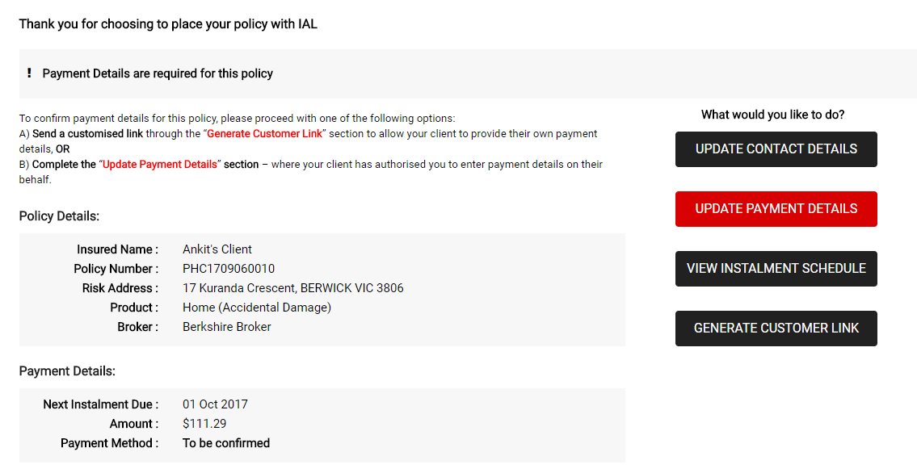

1. **Update Payment Detail Page**

The broker has to enter the payment details of client through which payments will be made.

1. Bank Details
2. Card Details

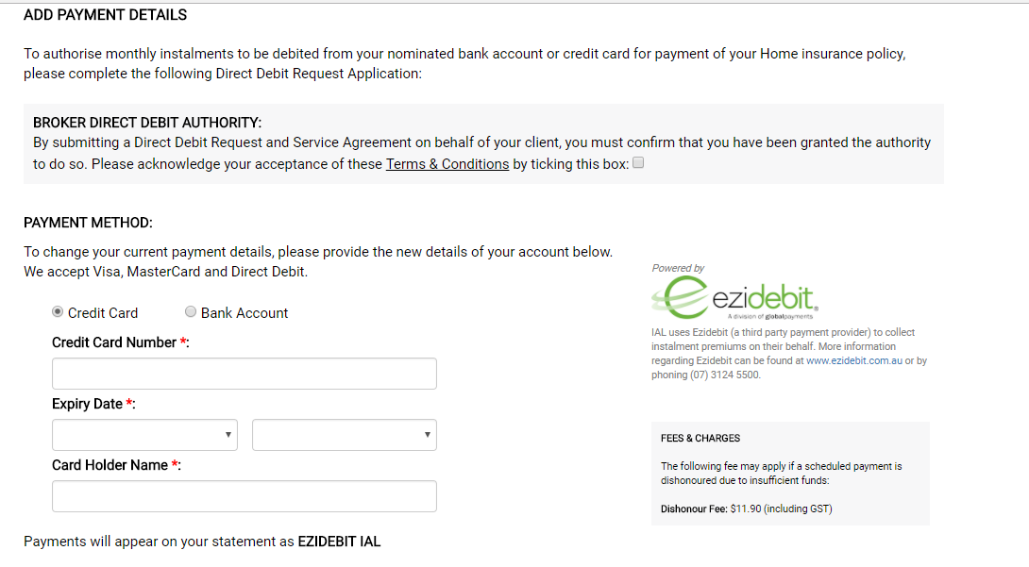

1. **View Installment Schedule Page**

Broker can view the installments schedule and their status (Successful or dishonor) on this page.

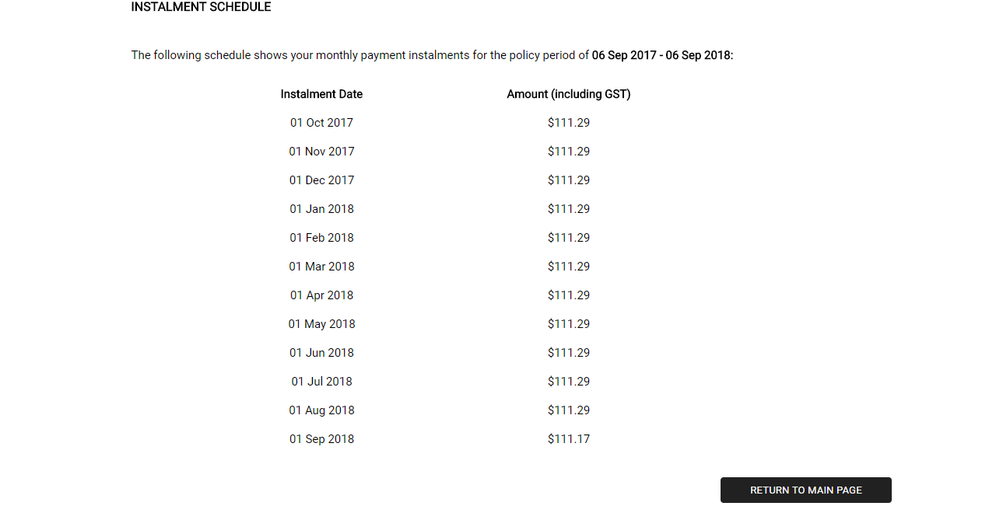

1. **Generate Customer Link**

If broker wants customer to open website than he needs to generate the Customer Link.

Note:-

The Customer link will get open up by passcode which will be sent on Customer Email Id.

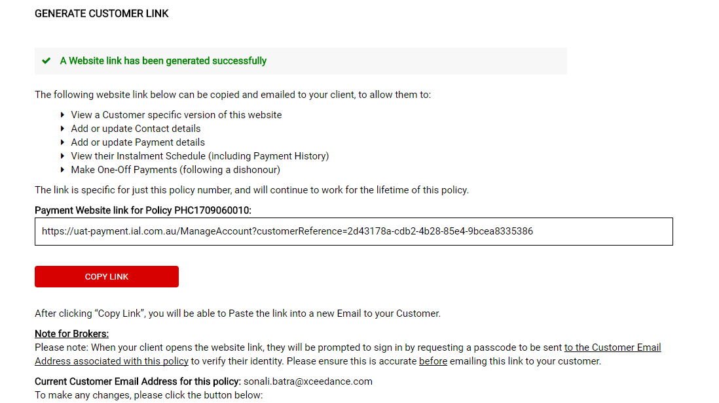

## 1.8 Referral

Referrals is a functionality by which the user can ask the underwriter to provide the appropriate premium if he/she is not satisfied with the premium provided by B3U (manual referrals) OR B3U is not able to provide the premium (automatic referrals).

1. Automatic Referrals – Driven by the business rules system is not authorized to directly provide a premium. Underwriter will receive the request and provide a premium via referral application. Examples of automatic referrals include:
   1. Building Sum Insured is greater than X amount
   2. Address not found
   3. Motor accessories amount is over X % of Motor Sum Insured
2. Refer Functionality – Referral request is triggered from SVU portal by clicking “refer” button and the request is sent to B3U (following screen print) and received on the referral application

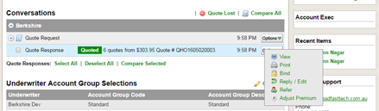

Fig 18

1. Referral Handling (Referral Application) – If an underwriter actions referral from the referral application, a response is sent from B3U to SVU which can either be an approved premium response or a decline.

**Example:** If the Sum Insured of Home was $2.7 M for which system is not authorized to provide a premium above $2.5M directly to the user, then the underwriter can provide a premium along with the referral factor which will be used in future transactions (multiplicative factor of enhancing or decreasing the system calculated premium).

|  |  |
| --- | --- |
| Sum Insured | $2.7M (Value) |
| Referral Condition | Sum Insured of Home (Name) |
| B3U calculated premium (shown to the underwriter) | $1000 |
| Underwriter’s premium | $1200 |
| Referral factor | 1.2 (1200/1000) |

Please find attached List of referral & sheet for referral Premium calculation



## 1.9 New Business Premium Calculation

**Home**

***Risk premium after premium adjustment*** = {((Home Risk Premium + Contents Risk Premium + Sum of Non-personalised specified item Sum insured* specified item percentage + Additional Benefit Cost + (Fixed Loadings / Discounts)) * (1 + Claims Expense) / (1 - MPD) * **Referral factor**)

***Adjusted Risk premium****= Risk premium after premium adjustment \** ***Cup and cap factor***

***Pre-tax Premium*** = Adjusted Risk Premium * (1- commission-policy expenses)

***Post-Tax premium*** = PreTax + GST+SD+FSL

**Landlord**

***Risk premium after premium adjustment*** = {((Home Risk Premium + Contents Risk Premium + (Sum of Non-personalised specified item Sum insured* specified item percentage) + Liability +Theft by Tenent+Rent Default Loss of Rent + Strata Title Mortgage + Additional Benefit Cost + (Fixed Loadings / Discounts)) * (1 + Claims Expense) / (1 - MPD) * **Referral factor**)

***Adjusted Risk premium****= Risk premium after premium adjustment \** ***Cup and cap factor***

***Pre-tax Premium*** = Adjusted Risk Premium * (1- commission-policy expenses)

***Post-Tax premium*** = PreTax + GST+SD+FSL

**Motor**

***Risk premium after premium adjustment*** = [Base Premium * {(Multiplicative Factors) + (Additive Factor + (Fixed Loadings / Discounts] * {(1 + Claim Expenses) / (1 - Multi-Policy Discount- Policy Expenses) * **Referral Factor**)

***Adjusted Risk premium****= Risk premium after premium adjustment \** ***Cup and cap factor***

***Pre-tax Premium*** = Adjusted Risk Premium * (1- commission-policy expenses)

***Post-Tax premium*** = PreTax + GST+SD+FSL

Please find attached sheets for calculation



# GLOSSARY

1. **Inception Date/Effective Date-** Policy Start Date
2. **Expiration Date-** Policy End Date
3. **Sum Insured** - Maximum compensation that insurer pays for any loss, damage, or injury.
4. **Premium**-Amount that Insured pays to Insurer to cover their risk
5. **Broker Fee**-The broker charges the brokerage fee for services such as purchases, sales, and advice on the transaction.
6. **Excess**-An **excess** is a contribution you are required to pay towards a claim you make on your **insurance** policy.